Mini project using Excel and Power BI
Jincy Elza James

Topic on : Analyzing sales on different categories
File name : Sales data sample
Data set source :
https://www.kaggle.com/datasets/pramodbhikajigaikwad/sales-data-sample
Introduction
This project focuses on the analysis and visualization of vehicle sales data using analytical tools to understand meaningful insights of sales trends over time , customer preferences, and market performance, by examining factors such as vehicle type, price and sales volume by using excel and power BI. The goal is to transform raw sales data into actionable insights for better business decisions.
Raw data :
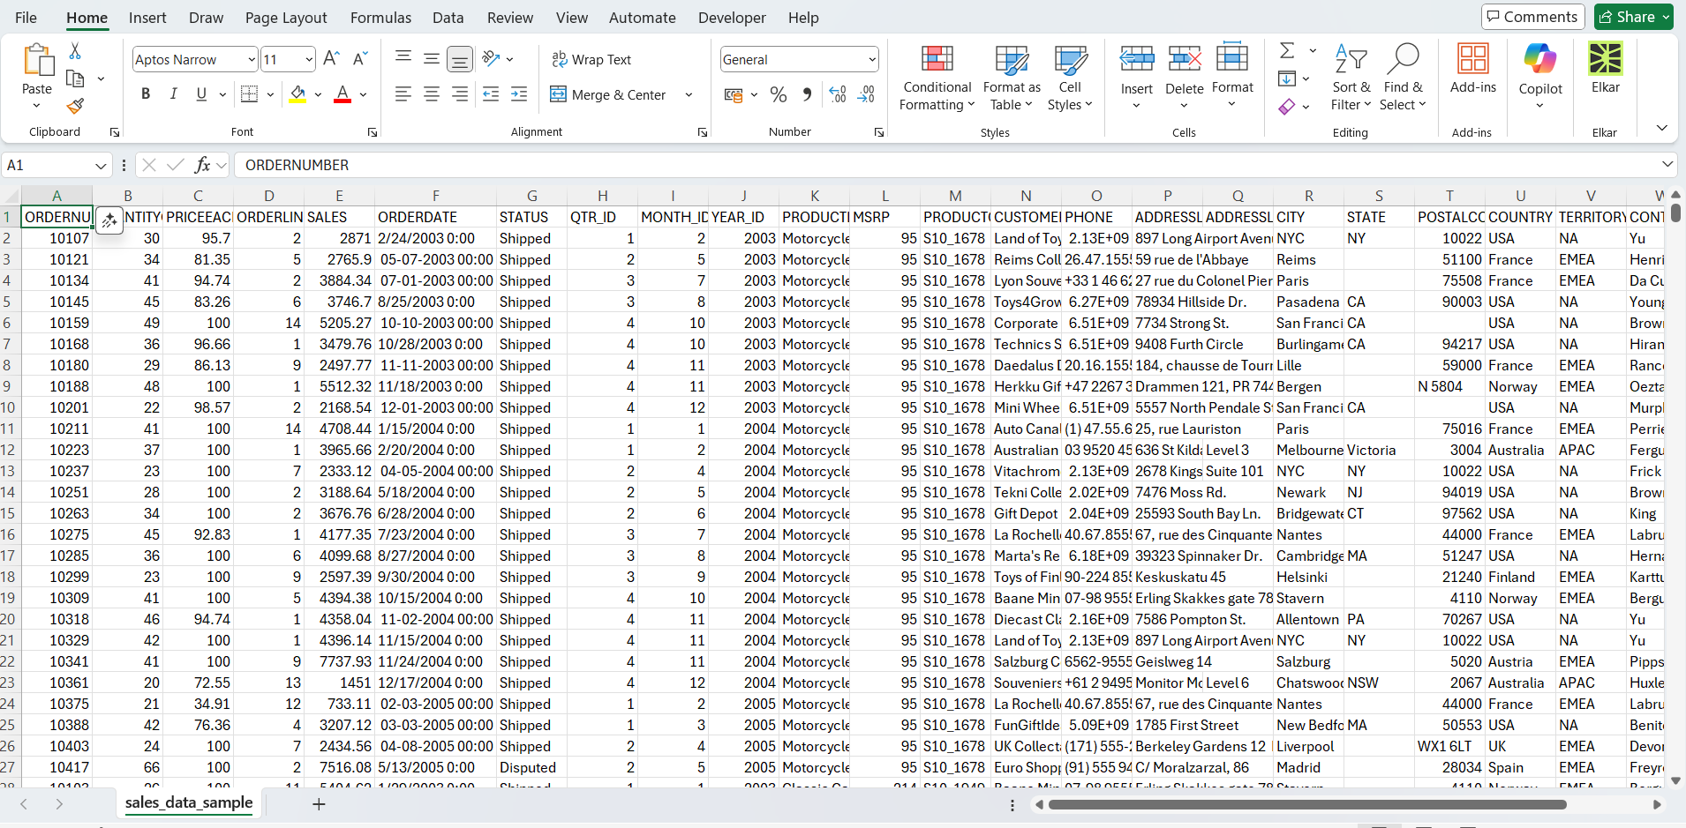
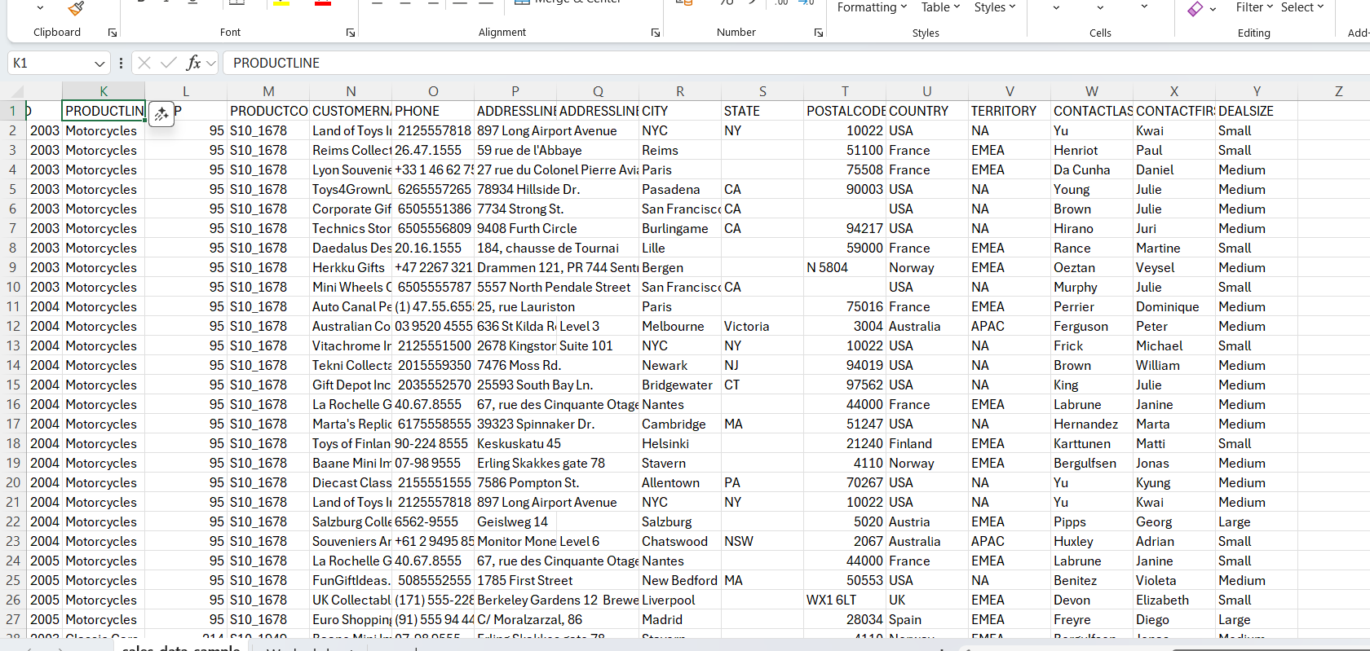

- Data cleaning :

First step is to identify the missing values and remove duplicate values.

To find duplicate values : Home conditional formatting Highlight cells rules Duplicate values.
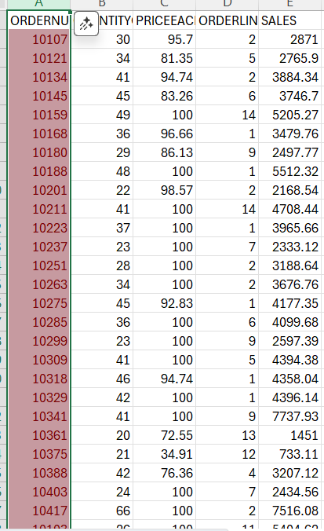

To find missing values : Use Count blank function of selected range or using Isblank function.

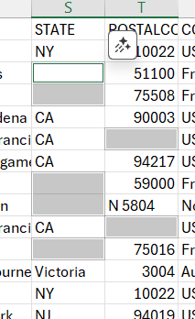
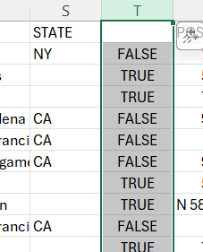

To remove duplicates :
Select all data remove duplicates Unselect all Select particular column ok.
Then duplicate values will be removed from data set.

To handle missing values :

Replaced with city name by using if function.
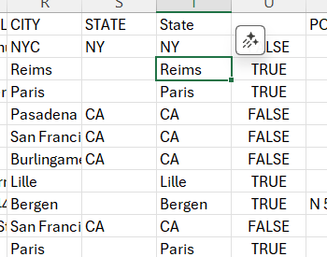

Date format changed :

Date format is changed by using Format cells.

Correcting inconsistent data :

Correcting inconsistent data by using find and replace option.
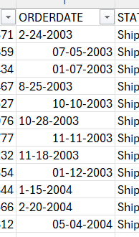
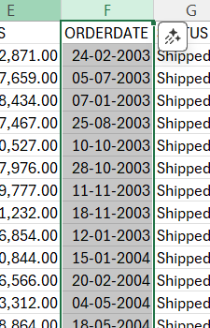

Combining data :

Combining address line 1 and address line 2 into single address column using concat function.

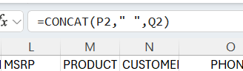
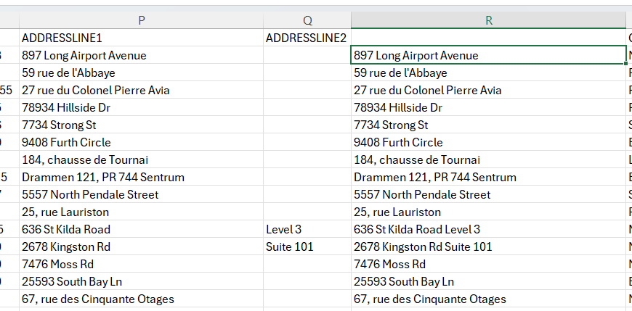

Combining First name and last name :

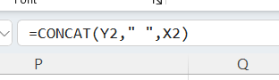
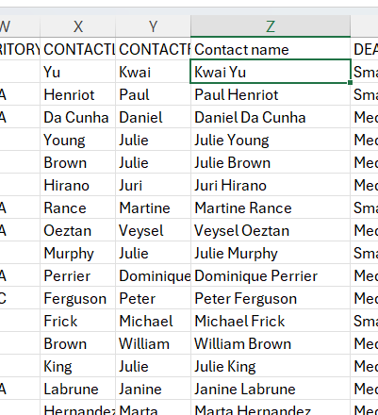

Convert number to currency format:

Changed number to currency format

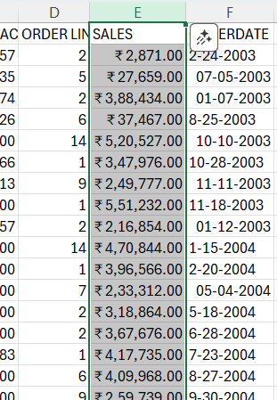

Cleaned data set :

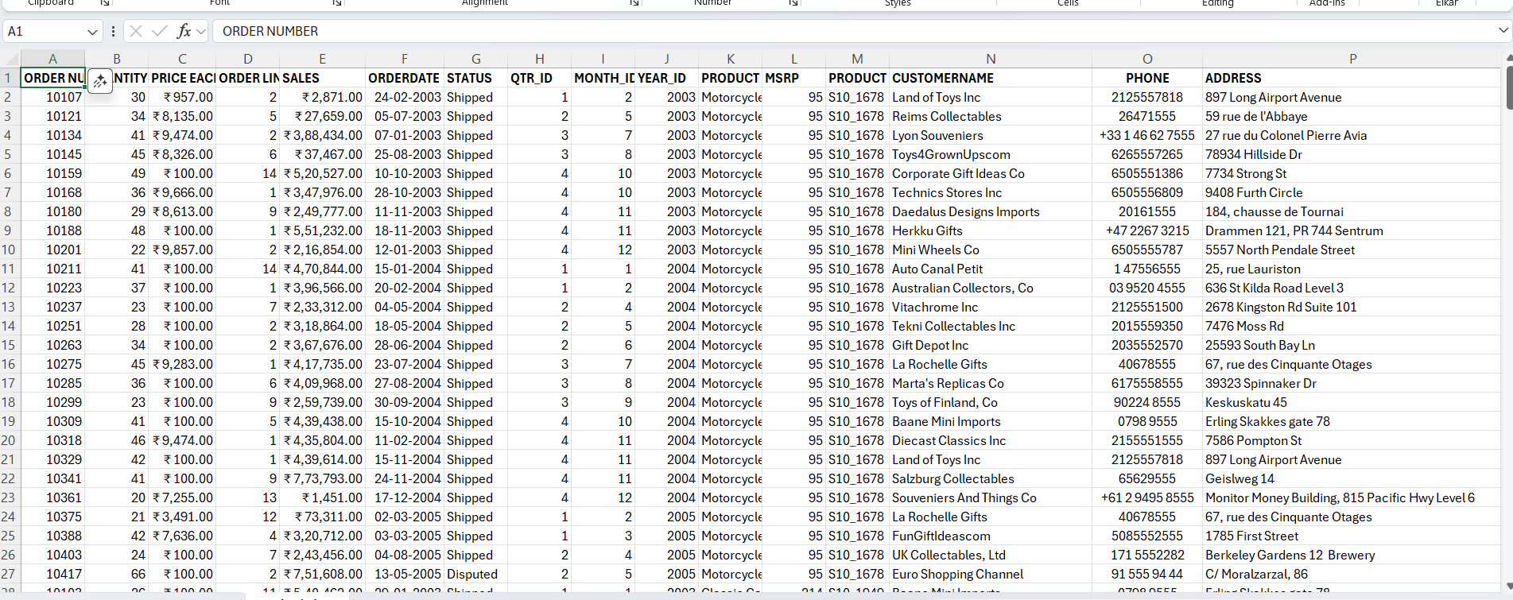

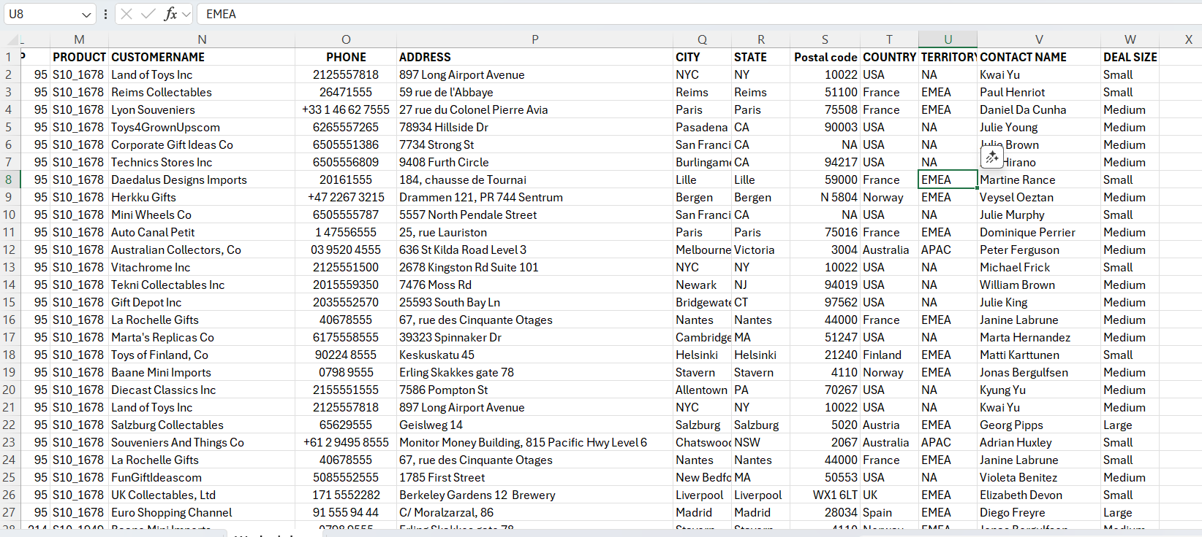
II Data analyzing using Power BI
Insert data from Excel :
Home get data Excel workbook select the file ok.
Then excel file will be visible.
- Add new column

To add a new calculated column go to home transform data transform data add new column enter name in formula bar :Total sales= Add column (Price each * Quantity orderd)
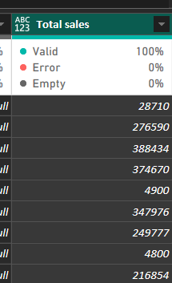

- Adding new table
To add a new calculated column go to home transform data transform data add new table enter table name in name box and select the needed table.
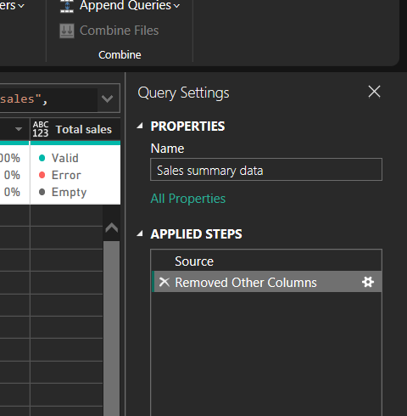
- Adding new measures
To add a new calculated column go to home add new measures name of the measure in formula bar = calculation.
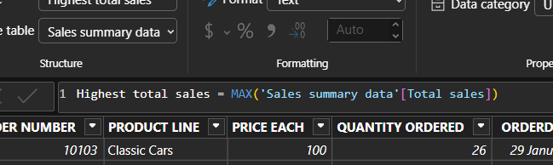

- Building the report

Go to home report view select the charts drag and drop the field change the format of chart in format visual.

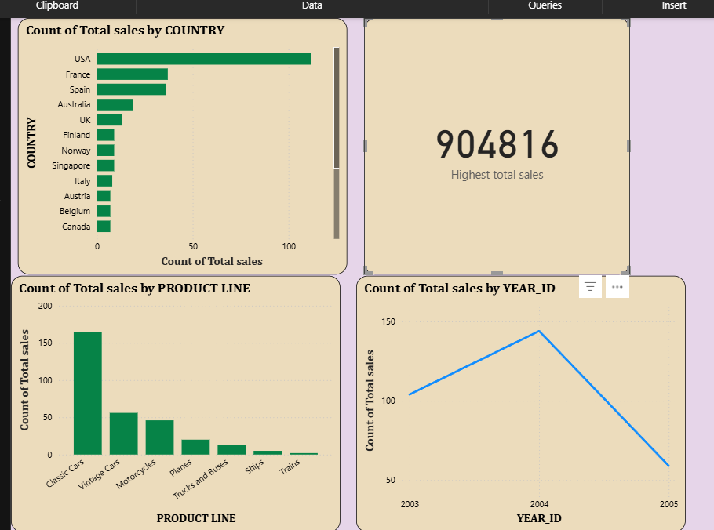

- Dashboard

Final report:

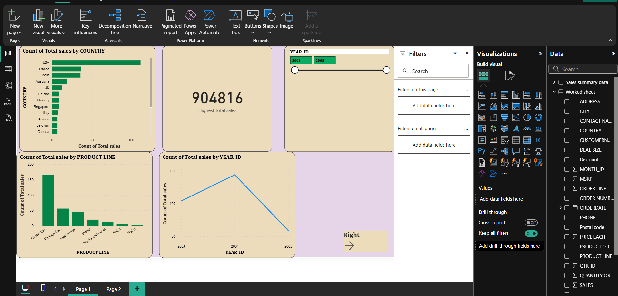

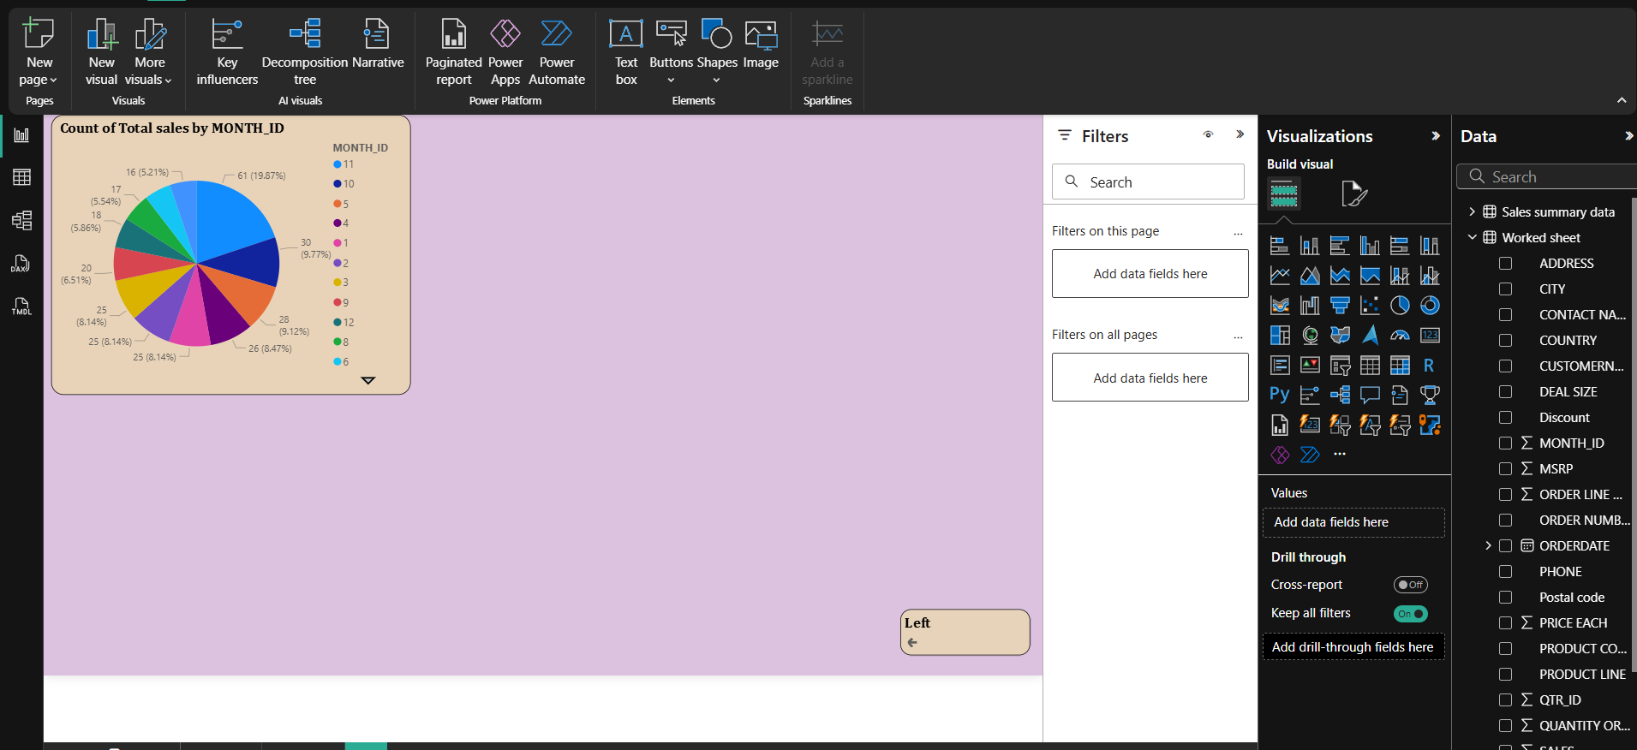

Conclusion

Through data analysis and visualization, this project transformed vehicle sales data into meaningful insights. Interactive dashboards enabled the tracking of key performance indicators and sales trends across regions.

